Scheduling something for a Work Group
Tip

Do you have a need to schedule something for a work group team, such as a paralegal and attorney.
This is very easy to do with the Calendar.

- Open up a screen to Add a calendar event from either a case, eligibility, the Add tile, etc.
- Go to the ‘or Set for Multiple People’ tab on the Calendar slip.
- Highlight the people you want by clicking on them.
- Fill out the information about the tickle reason, etc. The case number will be there if you opened the calendar slip from a case.

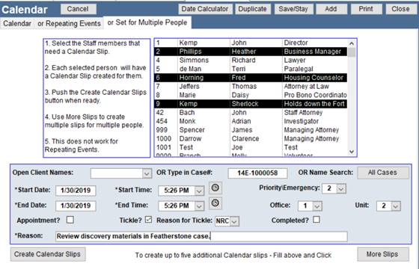
- To enter multiple slips for multiple people, click on the More Slips button and enter the additional information. (not done here)
- Press the ‘Create Calendar Slips’ button then Close the calendar slip.
- Below is what the Calendar View search screen displays. Note the three entries tagged as multi-person events. This event will show up on each of the advocate’s calendar.

