Random and a Select Group of Cases
Tip

This time of year funders want reports and information about the cases you handled last year. Often they ask to see a certain number of previous cases.
There are two queries that are available in the system that make this easy for you. The following will not only show you how to run the report but also how to get into it so it runs with the criteria you want, such as funding code, etc.

It is important that you remember that these queries are easily modified (as described below) to give you the information you need.

- Generate a list of any number of Random case numbers
  - Find the report
Finding the report is easy. You can use the Preview Search, Tree View or Report Selector Forms to locate it.
We’ll use the Preview Search Report Finder.
    - Go to Reports on the Ribbon Bar
    - Click on the Preview Search button
    - Type in ‘Random’ next to the Report Description Search Field (Rpt Description)

Here we have done all three steps.

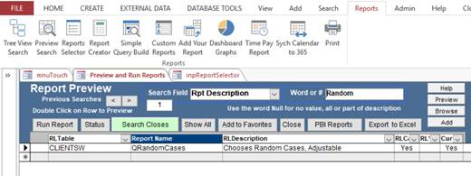
    - Click on the Run Report button, you will be prompted for dates. Put in a small date range just to get started.
The report is set to give you 100 Random cases between the two opened dates. This is easily changed.

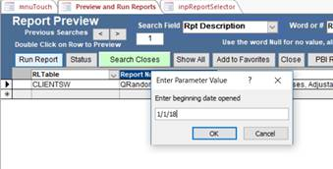

You will get a list of cases that satisfy your list. To modify this report to give you exactly what you want right click on the tab and choose Design View.
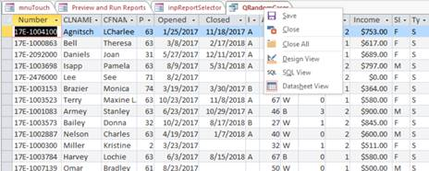

Go to the Returns field and type in the number of Random Cases you need during the period you will run it for.
Then click the ! Run button to get the cases you need. You can add fields or other criteria to further limit or expand the report.

Note: Every time you run the report is will give you a list of different Random cases. So you should print or do a make table query to save the list.

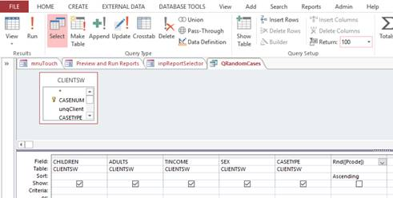

- Choose every Nth Case between two dates opened

- Repeat the above steps with the following changes to Find the Report
  - Change the Rpt Description to Rpt Name using the pull down.
  - In the entry field type in *Nth*. This is using wild card to find all the reports with ‘Nth’ in their name.

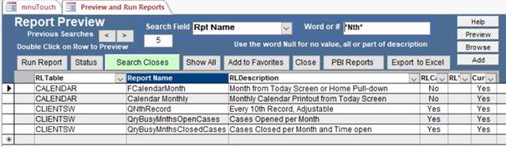
  - Click on the QNthRecord Report and then click the Run Report button to run it.
It displays every 10th case between the two dates.
  - To modify the report, right click on the report and go into Design as explained above under the Random Report.

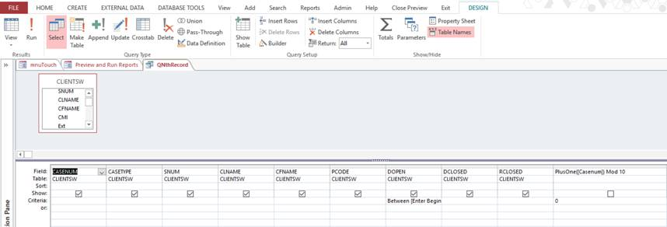
  - Go to the last column and drag it wider so you can see “PlusOne([Casenum]) Mod 10” Change the 10 to whatever number you want, e.g., 30 for every 30th case
  - Add any other restrictions you need to the grid, such as advocate, office, etc.
  - Generate the report using the ! Run button.

Note: To run either report using Date Closed rather than Date Open, Cut the criteria form below DOPEN and paste it below DCLOSED on the Criteria Line. You might want to change the prompts from :

Between [Enter Beginning Date Opened] And [Enter Ending Date Opened]
To
Between [Enter Beginning Date Closed] And [Enter Ending Date Closed]

Although the report will run fine if you don’t it just won’t say the correct field in the prompt.

