
The Search Screen as a Report Writer
The Search Screens in Prime are one of the most used forms. However, the majority of people are unaware of the ability to use them as a powerful report writers. What this article will show is just two features that increase the usefulness of these screens. The features shown will work for the vast majority of search screens in the system.
- Set Dates
Reports are seldom done for all cases in the system. Most times the information is needed for a set of cases opened or closed within a specific period. Prime makes it easy to set those dates to the ones you need.
Open up the Client Search Screen for this example (however almost any other Search will work as well). Let’s say we want to have a report for cases closed during a certain period.
- On the Ribbon Bar click on the Search tab to see the features you need.
- Next, single click on any Date Closed (Dclosed)
- Go up to the Sort & Filter group on the Ribbon Bar and click on the Funnel
- A pull down appears near date closed that gives you the choice of opening date filters. Click on it.
- What shows is a list of about 24 selections you can use to set the date closed for a period, such as between two dates, last week, or last month.
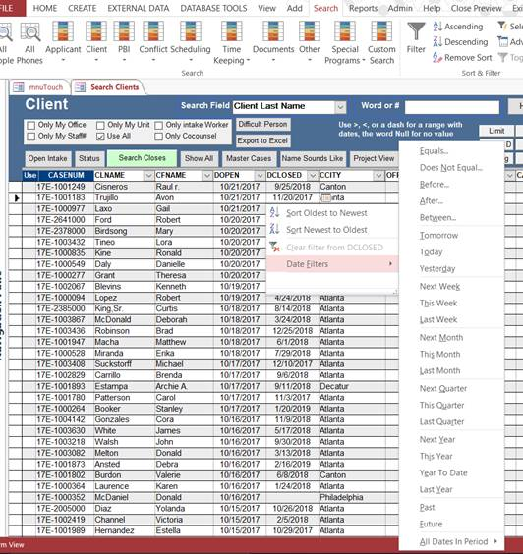
- Using Advanced to See a Query Grid
This next example will be familiar to anyone who has done custom queries in Prime. However, what is useful is that this can be tied into the Search Screen to display virtually anything you want. Let’s set up an example where we want to see:
All open cases
For clients over the age of 59
Sorted by
Office and then
By Advocate and then
By Problem code.

We also want to display the age of the client. Although this seems impossible to do with a search screen, it really is relatively easy.
  - Show the Age of the Client
The first thing to do is change the CaseType column to age by clicking on the pull-down and selecting age. (To find it quickly, start typing age after clicking on the pull-down).

  - Next we click on the Advanced button on the Ribbon Bar in the Sort & Filter group mentioned above. Then select Advanced Filter Sort and a grid appears.

  - Delete anything there by clicking on bar above the column head till the whole column turns black and tap Delete on your keyboard.

  - Type these field names in at the top of each column.
Officenum
Snum
Pcode
Age
Dclosed

  - Enter the following on the Criteria Line below the column headings listed.
Age >59
Dclosed Is Null

  - Add the Sort Levels you want by choosing Ascending under each of the below columns.
Officenum
Snum
Pcode

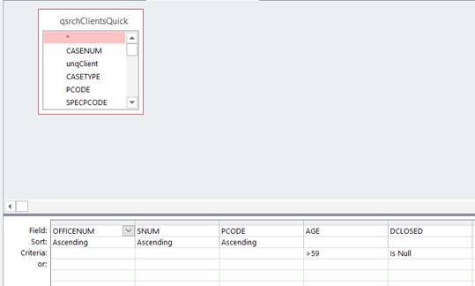

  - Apply it to the Search Screen
Go to the Ribbon bar and choose Advanced then Apply Filter Sort
What you get is a Search Screen that:
Displays Age
Lists Clients over the age of 59
Who have open cases
Sorted by Office, Staff Number and Problem Code

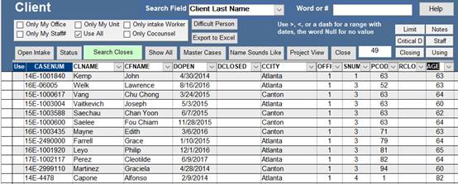
You can now print the list out, export it to Excel, etc.

