Duplicate the Client fields that you need
Have you ever used Smart Duplication but found that the fields that were setup to be duplicated weren’t quite the ones you wanted? The solution to this is very simple. But first it would be good to do a review of how Smart Duplication works.

Smart Duplication

Smart Duplication is selected by choosing the ‘Duplicate’ button on the top of the Client Intake. It allows you to copy existing client data with the option of also copying Family, Eligibility and Case Notes. You can choose to substitute different values in the new record, such as problem code and advocate. This means the new intake will be created containing that new information, making it immediately ready for use. If you have a need to duplicate only certain fields or want to duplicate fields beyond the Standard duplicate method, you can choose to use the Custom or Selective duplication methods explained below.

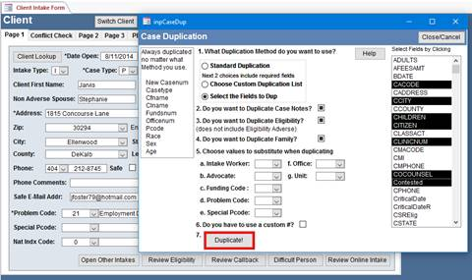

Three types of duplication

Standard Duplication
Standard Duplication works like the duplicate system in previous versions of Prime. It is preset to duplicate the same fields that the previous versions duplicated. The fields duplicated are:

Intake Type | Case Type | Name | Complete Address | County
SSN | Birthdate | Gender | Race | Income Source
Adults | Children | Office | Citizenship Verified | Total Monthly Income
Unit | Phone | Funds | Marital Status | Advocate

Custom Duplication
Uses a list of fields you or someone else has built with the names of the fields you need to duplicate. When you select Custom Duplication a pull down appears listing the custom duplication methods previously setup.

How do I set up my own custom duplication list?
The way to setup your own custom list is explained below in the Selective Duplication section.

Selective Duplication
You can use Selective Duplication one of two ways. It can be used:
For a one time duplication that you need
or
To create a custom list used in #2 above

When you pick Selective Duplication a list of fields appears that you can select from by clicking on them. Certain fields are not listed because they are always duplicated. The list of these fields appear to the left on the Duplication pop-up.

Once you are done selecting your fields click on the ‘Duplicate’ button. You will be given an option to save this list as a custom list. An Option #7 will appear that says Save List. Save your list, give it a name, and it will then appear in the Custom Duplication List and you won’t need to select the fields in the future, rather choose its name from the Custom Duplication method pull down.

You can name the list anything you want, such as Doug, Housing Unit, Office 2, etc.

If you wish to duplicate Case Notes, Eligibility, and/or Family, you have to check these actions.

If you wish to substitute values, such as problem code, intake worker, or office number, change the values by selecting them from the pull downs. Note: Substitute values works for all 3 methods

Keystrokes bonus feature
Most people are unaware that Access has certain ‘hot keys’ that will duplicate things. You need to experiment with these as not all have been tested.

- [Ctrl]+[;] inserts the current date.
This is invaluable if you keep historical records, or include the date in any notes or other fields in your database. It not only saves time, but ensures data accuracy and keeps you from having to remember the date.
- [Ctrl]+[:] inserts the current time.
Like the Insert Date shortcut, this feature can save more time than you realize, and it also helps to keep your data accurate.
- [Ctrl]+['] inserts the value from the same field in the previous record.
When you need to enter several records consecutively, you probably find that many of the fields are the same from record to record. Using the clipboard to copy data can help, but you may need to enter several fields of duplicate information (your name in one field, the date in another field, and some generic comments in a third). Use this shortcut to insert the same field's value from the previous record.
- [Ctrl]+[Alt]+[Spacebar] inserts the default value for the current field.
This comes in handy when you start typing, and then realize that you should have kept the default.
- [Ctrl]+[Z] undoes the last action.
- [Ctrl]+[A] selects all text in the current field.
- [Shift]+[F2] opens zoom box to edit the current field in its own, larger, dialog box.
- [Spacebar] toggles the value of a check box or option button.

