Document Tracking/Management
The Document Tracking/Management System allows for an organization-wide document management system and brief bank. The system can hold documents for retrieval that are not only related to cases but also ones concerning other things, such as newspaper articles about the organization.

What is Document Tracking?
Understanding Document Tracking in Prime Case Management means understanding four basic concepts.
- Forms, Letters or Digital Files (such as videos, pictures, etc.) are stored on a hard drive and accessed through case management. Documents, as referred to above, mean any file that can be stored in a digital computer file. These could be Word, PDF, JPG, MP3 or any other type of digital files. Pictures or voice recordings from your phone are examples of these.

- The Documents can be associated with a case or not. Many times your documents such as a deed, a will, court pleadings, etc. will be related to a particular case. Other times, you might have a newspaper article about your organization or the text of a presentation one of your advocates did in front of a community organization. These wouldn’t have specific cases associated with them, yet they till can be stored.

- An actual copy of the document can be stored inside of the SQL Server database or the document’s location can be stored.
  - When the document is stored inside of the SQL Server, it is a copy and it is stored in the format it was created in. The original document still exists at its beginning location. When you tell Prime to open the stored document, it finds the database record storing it, looks at the type of document it is, and then opens it with the appropriate application (such as Excel).

  - You also can work with the original document and just store the path to it. As you are aware, when working with files on a computer, you need both the name of the file and the address about where it is located. If we look at the file name C:\Users\Kemp\Smith Case\Complaint.docx, we see that the file:
    - Is located on drive C:\
    - It is in a Folder caller Users. Inside that Folder there is a subfolder called Kemp. Inside of Kemp is a subfolder called Smith Case.
    - The name of the file is Complaint
    - The file type is a Microsoft Word Document (the extension is .docx, which is a Word document).
    - If we ask to open the file, it opens the file with the appropriate application, here Word.
Storing just the path to the document for several reasons:
- The drive letter seen by one computer might be different when using another computer. For example, my drive C: is different than the drive C: on ‘Joe’s’ computer. This method would require documents to be stored on a shared drive that every computer would see as the same drive letter, such as S:\.
- Also storing the path to the original document presents the danger of inadvertent or unauthorized changes to the original when it is pulled up and examined.

- Finding a Document in Document Tracking can be done three ways:
  - Opening the case it is associated with and going to the Document Tracking button. You can then click on it and click the Open File button.
  - Using a Documents Search Screen, which allows finding documents using either:
    - Information stored with the computer file such as name of the file, date of the file, size, type (.PDF, DOCX, MP4, etc.)
    - By using descriptions you added to the document find such as a:
      - Textual description
      - Relation to a particular problem code
      - Whether the document is brief bank quality
      - Etc.
If you use only the file information, no additional action is needed by the user. However, to make the file easier to find, you should fill out some of these additional descriptive fields, as shown in the second screen shot below.

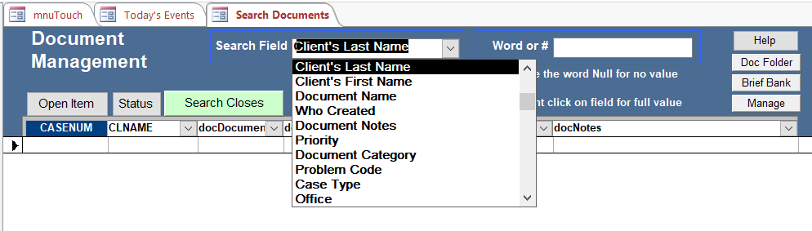
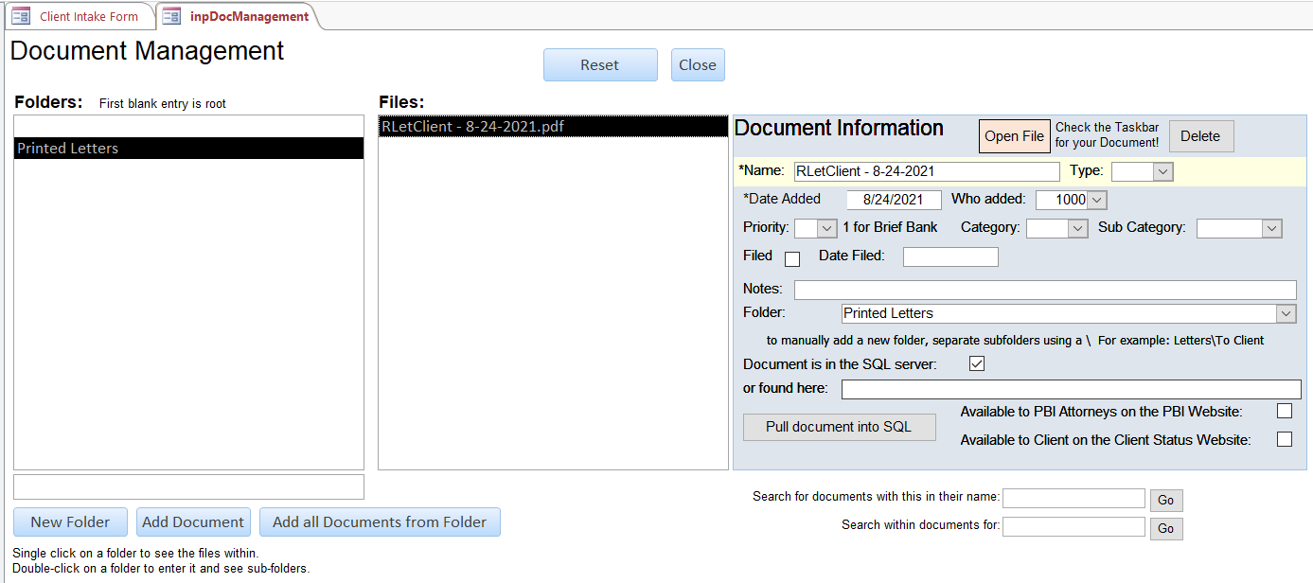

  - Using the Document Text Search Screen to look for specific content within the document (depending on the document storing words rather than sound, pictures or videos).

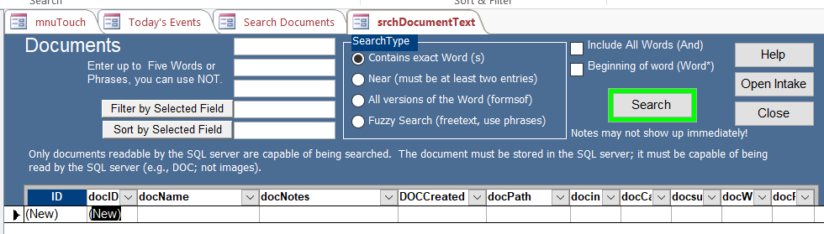

The Ease of Using Document Tracking

Documents can be entered into tracking one of two ways; automatically or manually.
  - Automatic Document Entry in Six Easy Steps
Although it is possible to link Prime to scanners, etc. to get documents to be entered automatically, this is dependent on many custom network and device settings. Therefore there is only one standard automatic way to enter documents into Prime, which is through the built-in form letters.

    - Create a Form Letter using the form letter button on the Client intake. (This is on the Tools Tab for the latest version of Prime or on Page 3 for older versions.)
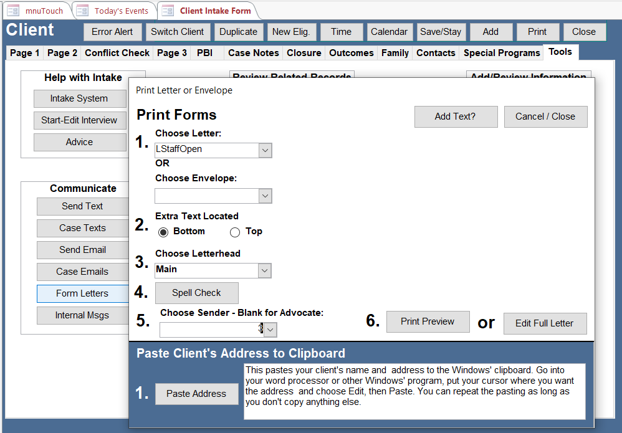

    - Press Print Preview. You are asked if you to want save the textual content of the letter to your notes. You can answer Yes or No. However, we want to archive an actual copy of the letter in the Document Tracking. Press the Archive button in the upper left corner when you see the print preview.

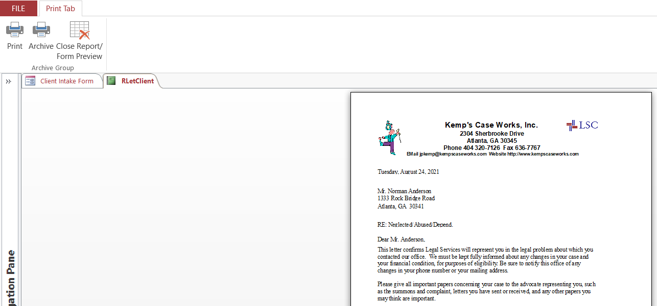

    - A Message appears telling you the save was complete

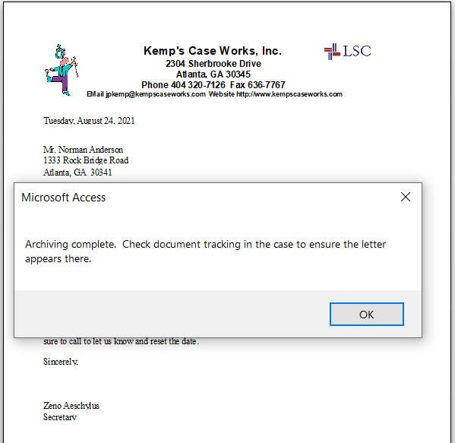

    - To confirm it was stored, press Document Tracking button on the Tools Tab (earlier versions of Prime have the button on Page 2).
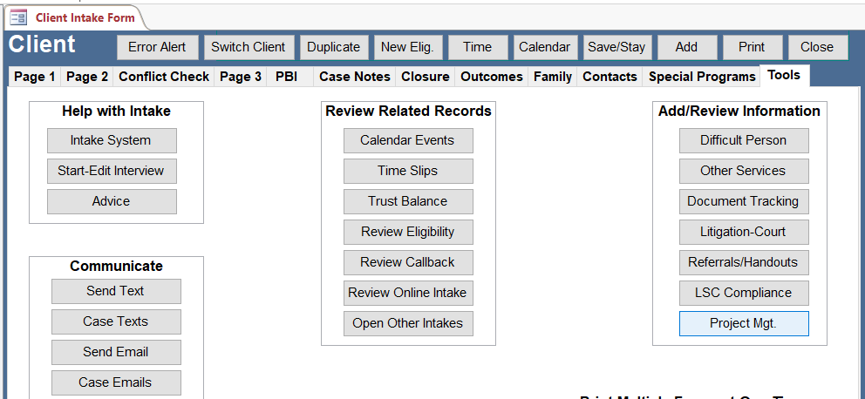

    - We confirm it was created by looking for a folder called Printed Letters and a copy of the letter stored there (RLetClient). Note the Document Information form that appears. It allows us to add notes and further refine our indexing of the document.

    - If we press the Open File button a copy of the letter in PDF format opens in our designated PDF viewer (here Adobe Acrobat). It may be necessary to go to the Task bar at the bottom of the page and click on it to see it. A copy of the letter is now stored in the SQL Database, looking exactly the way it was sent to the client, complete with graphics.

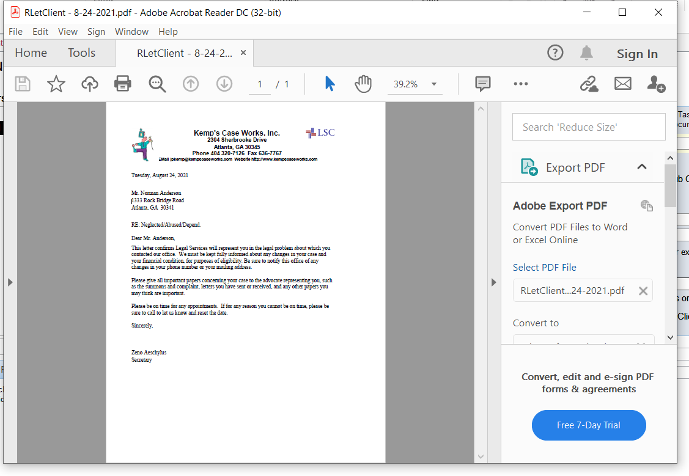

  - Manually entering a case related document in seven easy steps
You may add documents to an existing folder or no folder at all.
    - First Press the Document Tracking Button while in the case
    - Choose the folder you want the document to be stored in by clicking on it. Double click on a folder to look at sub folders under it.
    - Click on the Add Document Button
A message opens telling you in what folder your document will be stored (if any). You have the ability to cancel out, if you want to change the folder placement.

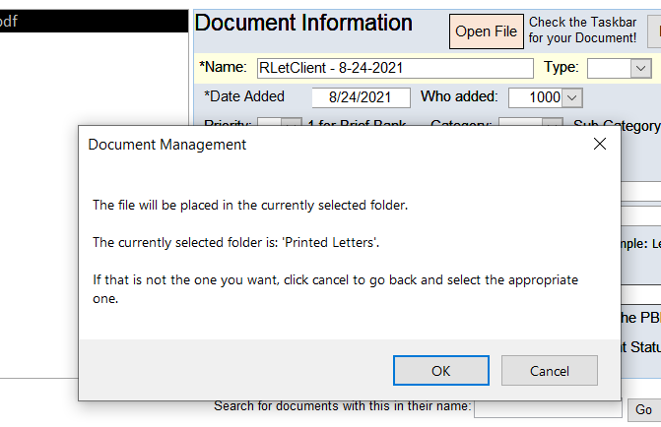

    - Search For, Locate, and Copy your Document from the Disk
Now an "Associate a File with a Kemp’s Case" box appears. Use this to find and select your document. Once you have selected it, press the Open button. The system will copy the file into the database. The file should now appear in the Files box.

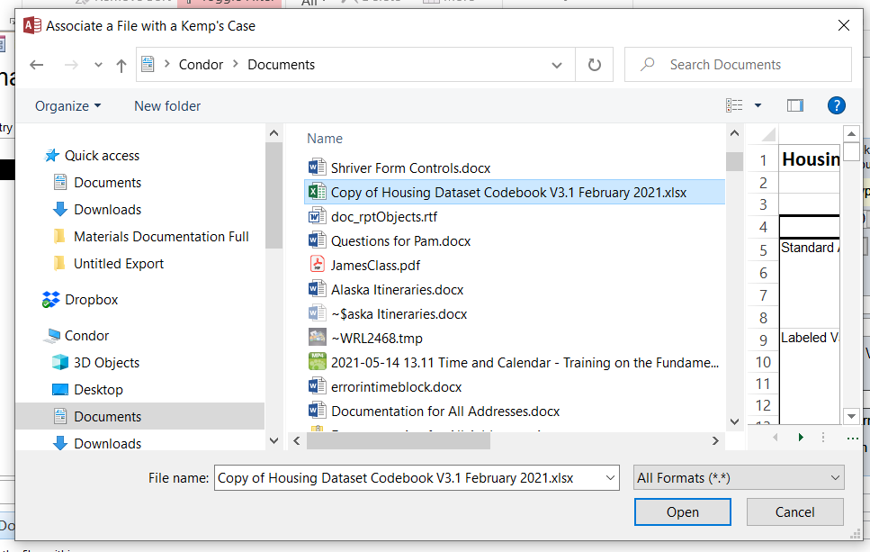

    - Document Properties and Adding indexing information
A Document’s properties shows up in the ‘Document Information’ box. This box shows up when adding a new document or looking at an old one. This box also has other features.

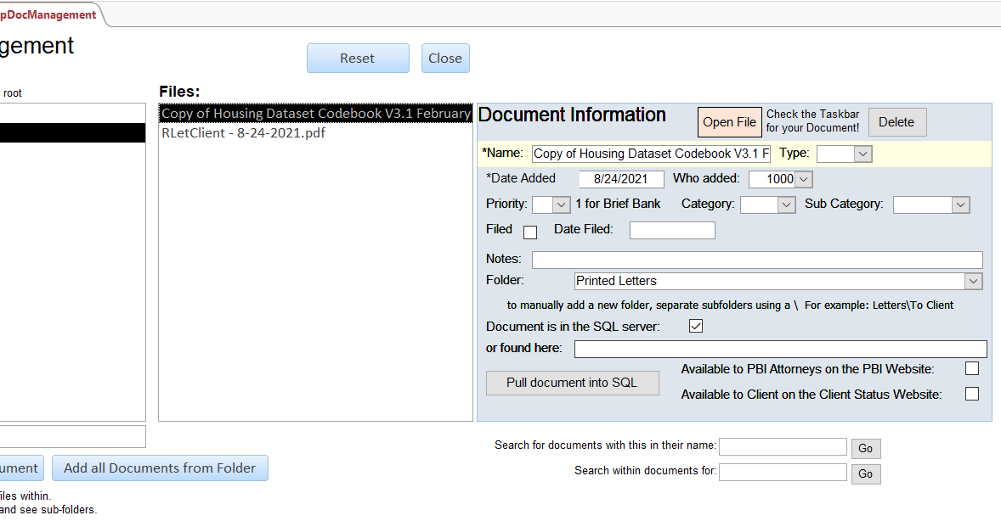
      - Open the Document
Click on ‘Open File’ to open the document for viewing
      - Delete – Delete this file from document management
      - Name – You can change the name here
      - Type – Indicate what type of document this is (answer, brief, memo, etc.). Your organization’s Administrator can easily add other types to this pull down list.
      - Date Added – The date the document was added
      - Who added – The staff number of the person who added the document
      - Priority – Whether the document holds some priority (For example, a 1 in priority means the document is brief bank quality and may be of use to others.)
      - Category – Problem codes you can choose to categorize this document
      - Sub Category – National index codes for subcategory
      - Filed – Whether this document was filed (in court, etc.)
      - Date Filed – When the document was filed
      - Notes – A textual description of the document
      - Folder -- the location of the file within the folder structure system
      - Document is in the SQL Server/or found here – This box is checked when the document is stored within the SQL Server. If it is not, the path to (location of) the document should be in the ‘Found here’ field.
      - Pull document into SQL – If only the path is stored, you can choose to change this and store a copy of the document in SQL by clicking on this button. The document has to be at the shown path for this to work.
      - Available to PBI Attorneys on the PBI Website – For those organizations that have the optional Online PBI/Attorney Portal, you can make this document available to the attorney for download via the web by checking this box.
      - Available to Client on the Client Status Website – For those organizations that utilize the online client status option, checking this box allows the client to access the document. This permits clients to check on the status of their case by logging into a secure website.
    - Adding Multiple Documents – Moving files into Document Tracking
Most people organize a case file within a folder on their network system disk. Somewhere on the server there might be a folder with the client’s name or case number on it where all documents relevant to the person’s case are kept. To make it easier to move these files into Document Tracking (without adding each file individually), you can use the "Add All Documents from Folder" button. The system then pops up a box that reminds us of the folder where these files will be stored. Then a Select a Folder box allows us to select the folder. Select/highlight a folder and press Ok. All documents in that folder will be placed in the Document Management system.

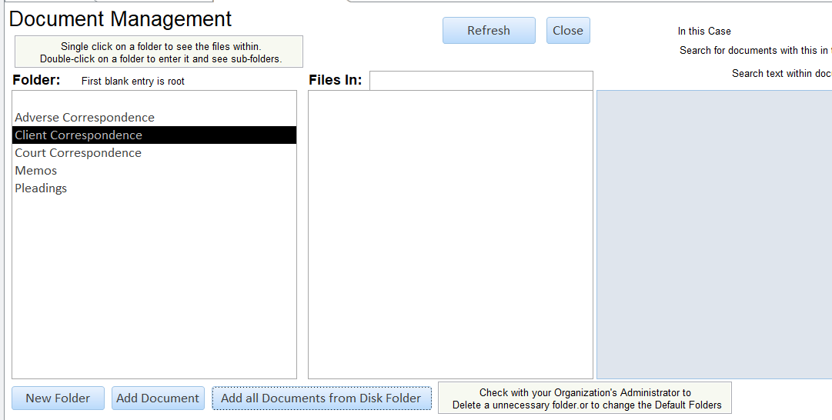

    - You’re done – A copy of your document can be pulled up at any time.

  - Adding Documents that are not Case Related
Non Case Related Documents are those which are not tied to a particular case. These are documents applicable to any number of organization functions, including a brief bank, organization policies and procedures, and just about any other type of document you can think of.

The processes are generally the same for Adding Folders/Subfolders, Adding a Document, Adding Multiple Documents, Opening a Document, Deleting Documents, Modifying Documents, Document/Folder Properties, and Search between case related and unrelated Document Tracking.

Follow these steps:
    - Go to the Ribbon Bar
    - Choose Add
    - Choose Other
    - Choose Documents NonCase
    - Follow the normal steps for adding a document
    - Note: Folders can be setup in the Non Case Related document area.

  - Deleting Documents
To delete a file, choose the file in the Files box, then click on the "Delete" button in the Document Information page. Some organizations want Document Tracking to be permanent and choose to disable this feature.

  - Modifying Documents
Changing a document saved on the SQL server using document management does not change the original document located elsewhere. You can open a document, modify it, and then save it as a separate document (perhaps with a version note in the title to indicate it is a subsequent version) in the system.

  - Changing Names – To change the name of a document, first select the document. When the Document Information page shows, change the name in the Name text box.

  - Changing Folders/Location
To move the document to a different folder (or to rename the folder that it is in), choose the file in the Files box. In the Folder text box, change the name of the folder list. Each level is separated by a slash "\". So, for example the first folder level appears, then a slash, and a subfolder within that folder, then a slash, and another subfolder appears.

For Example, if you have a folder called "Correspondence" with a subfolder called "Court Documents" that has a subfolder called "Appellate Court", the Folder text box would look like this:
Correspondence\Court Documents\Appellate Court

If we wanted to move a document from the "Appellate Court" folder to a "Supreme Court" folder in the same "Court Documents" subfolder, we would change that to:
Correspondence\Court Documents\Supreme Court

This is much like a Windows Explorer application showing files on a hard drive:
C:\Windows\System32\drivers\Description.txt

  - Folders
The Document Tracking system allows you to add an unlimited number of folders and subfolders under your case. This means you can store thousands of documents that pertain to a single case and keep them organized.
    - Displaying the Folder Tree
Only the Root of the tree of folders is displayed. Double click on a folder to show the subfolders beneath it.
    - Displaying the Files in a Folder
Single click on a folder to show the files contained in that folder.
    - Adding a New Folder
Put your cursor on the level you want your new folder to show up under. For example, click on the blank line to put a folder on the root.
    - Press the Add a Folder button. If you have a current folder highlighted, it will create a folder under that highlighted folder. Otherwise the folder will be on the root of the tree. Remember you must double click on a folder to see the subfolders underneath.

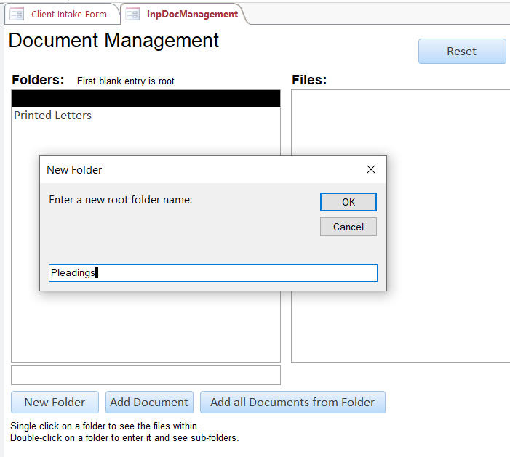

The resulting Folder.
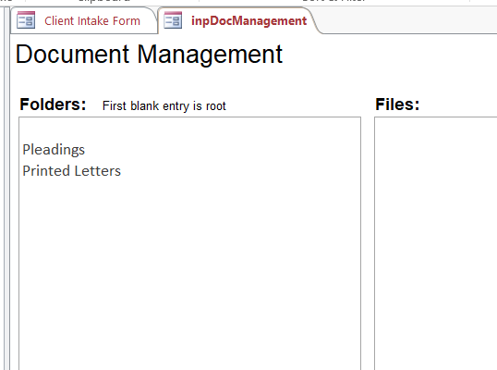
    - Clicking on the folder shows you the contents of that folder in the Files box on the screen

  - Navigating Folders
    - Default Folders
In the latest version of Document Management, there are default folders that show up when you press the Document Management button from a case for the first time. For older cases, the default folders will be supplemented by new folders created specifically for this case.

The default folders are setup in a table called subDocumentFolders. Your organization’s Administrator can easily change this list so the list of folders are added to, deleted or renamed.
      - Go to the Admin choice on the ribbon bar
      - Select Setup Tables
      - Pick the Doc Tracking Default Folders choice
      - Change the folders in the table that appears
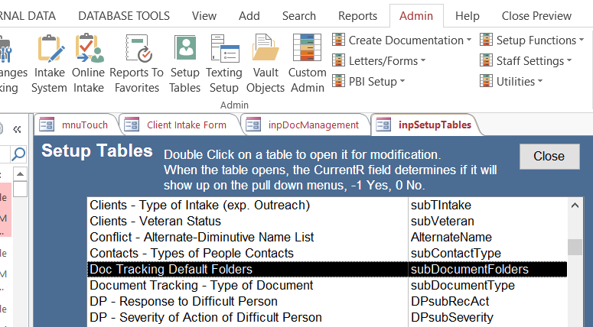

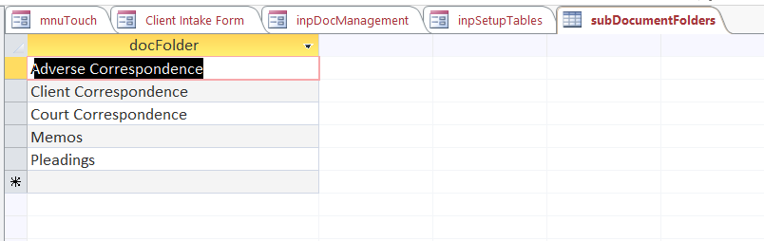

    - Showing files
When the Document Management screen first appears, no folder is selected and no files will appear in the Files box. To show files that are not put in any folder, click on the blank area at the top of the Folders box.
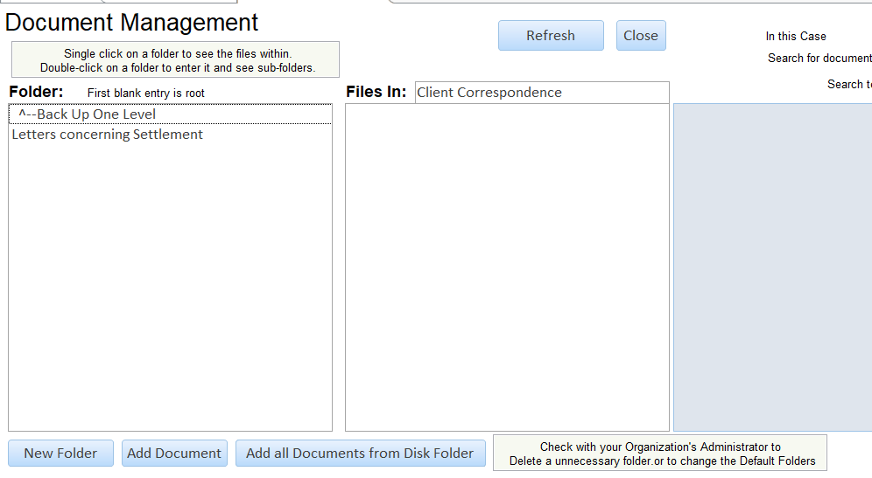

      - To show files in a folder, click on the folder.
      - To descend into a folder and see its subfolders, double-click on the folder.
      - To ascend out of a subfolder, double-click on the ^--Back Up One Level at the top of the Folders box.

